2017年高端班补录-每周一练
（新3年级 英语部分）
第1题：根据句意，选择正确的单词填写在横线上。
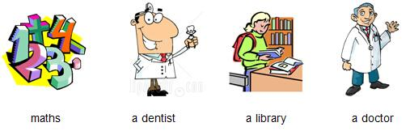
1. Children study this subject which is about numbers. ___________
2. You can go and see this person if your teeth hurt. ___________
3. You can read books here because it is very quiet. ___________
第2题： 选择正确的答句，补全对话。
Lara is cooking in the kitchen with her younger brother Joe.
1. Lara: Joe, can you help me? I’m going to make some biscuits.
Joe: _________________________________
2. Lara: Can you look in the fridge? How many eggs have we got?
Joe: _________________________________
3. Lara: Oh, Joe! Be careful! Now, how much butter have we got?
Joe: _________________________________
Lara: Joe! That’s cheese, not butter.
A. We’ve got five. Oops! Now we’ve only got four.
B. OK. What shall I do?
C. OK. Can I have some money, please.
D. Butter, butter… Here it is. We’ve got 100 grams.
第3题： 单项选择
1. – Hello, Daisy. What’s the matter?
- ___________.
A. What’s the matter?
B. My mobile phone isn’t working.
C. Yes, it is.
2. – Do you usually use the phone a lot?
- ___________.
A. No, I don’t use.
B. Yes, every day.
C. Yes, I use.
3. – What color phone do you want?
- ___________.
A. Black or blue.
B. No, thank you.
C. Yes, it does.
第4题： 选择合适的单词填空，补全短文。
doctor teacher shouted presents
My dad works in a hospital. He is a 1._____. Yesterday, it was his birthday but in the morning, we didn’t say ‘Happy Birthday’ and there weren’t any 2. _____. Dad came home at 6 o’clock. The house was very quiet. My family and Dad’s friends were in the living room. Dad opened the door and we
3. _____ ‘Happy Birthday!’ Dad was very surprised!

第5题： 阅读文章，回答问题（不超过三个单词）。
Mary and Vicky are sisters and John and Peter are their friends. It is Wednesday. They are at the library working on the computers. Mary is looking at a picture of a lion. John is looking at a picture of a panda. Peter is looking at a picture of a parrot and a bat. Vicky can’t see any animals.
1. The children are at ___________.
2. John can see a picture of ___________.
3. ___________ is looking at a picture of two animals.

答案：
第1题：maths；a dentist；a library
第2题：B A D
第3题：B B A
第4题：doctor；presents；shouted
第5题：the library；a panda；Peter

