三年级上学期期末测试卷
姓名_________ 得分__________
听力部分（40分）
一、听录音，选出你所听到的字母和单词。（10分）
( ) 1. A. Rr B. Ss C. Ll
( ) 2. A. Ii B. Aa C. Jj
( ) 3. A. HG B. GJ C. IY
( ) 4. A. IS B. QP C. ML
( ) 5. A. XY B. CK C. EF
( ) 6. A. fox B. fish C. frog
( ) 7. A. this B. that C. it
( ) 8. A. dad B. bag C. hat
( ) 9. A. cup B. duck C. chick
( ) 10. A. ten B. hen C. pen
二、听录音，给下列图片排序。（10分）
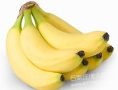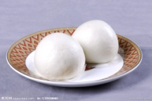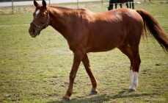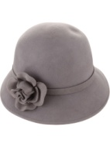
（ ） （ ） （ ） （ ） （ ）
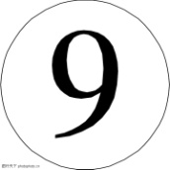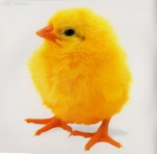
（ ） （ ） （ ） （ ） （ ）
三、听录音，选择正确的答语。（10分）
( ) 1. A. How do you do? B. Nice to meet you, too.
( ) 2. A. Yes, it is.Is it a bird? B. It’s a chick.
( ) 3. A. I’m fine, thank you. B. I’m five.
( ) 4. A. Hello, I’m Mr Dog. B. My name is Dog.
( ) 5. A. That’s OK. B. Thank you.
四、听录音，填入所缺的单词。（10分）
1. Hello, I am a _____.
2. I am your _____.
3. —Are you _____ Dog? —Yes, I am.
4. —What’s this? —It is a _____ egg.
5. —How are you? —I’m _____.
笔试部分（60分）
五、按书写规范写出下列字母的左邻右舍。（5分）
1. I i 2. C c

3. V v 4. R r

5. L l

六、补全单词，并写出其汉语意思。（5分）
1. p _ nda ( ) 2. d _ ck ( ) 3. s _ t ( )
4. b _ x ( ) 5. t _ n ( )
七、选出不同类的单词。（5分）
( ) 1. A. sheep B. rabbit C. dad
( ) 2. A. five B. pig C. one
( ) 3. A. foot B. map C. hand
( ) 4. A. blue B. white C. what
( ) 5. A. egg B. pear C. banana
八、单项选择。（10分）
( ) 1. Hello! I _____ Miss Bee.
A. is B. am C. are
( ) 2. —Sorry. —That’s _____.
A. OK B. fine C.nice
( ) 3. _____ apple for you!
A. An B. A C. The
( ) 4. —What _____ is your bag? —It’s yellow.
A. old B. colour C. time
( ) 5. Touch your _____.
A. arm B. this C. that
( ) 6. —What’s this? —_____
A. Yes, it is. B. No, it isn’t. C. It’s a book.
( ) 7. —_____ are you? —I’m nine.
A. How B. How old C. What
( ) 8. —Are you _____ Cat? —_____, I’m Miss Fox..
A. mrs; Yes B. Miss; No C. Mr; Good
( ) 9. Nice to meet you, _____.
A. too B. two C. to
( ) 10. —How are you? —I’m _____.
A. nice B. five C. OK
- It’s black and white.
- How do you do?
- No, it isn’t.
- Yes, I am.
- My name is Qiqi.
七、给问句选择正确的答语。（10分）
( ) 1. Are you Mr Pig?
( ) 2. Is it fat?
( ) 3. What’s your name, please?
( ) 4. How do you do?
( ) 5. What colour is it?
八、情景交际。根据情景，选择正确答案。（10分）
( ) 1.你和新朋友初次见面很高兴，可以说：_____
A. Nice to meet you. B. Hello.
( ) 2.小猪想问对方是不是狐狸先生，可以说：_____
A. Are you Miss Fox? B. Are you Mr Fox?
( ) 3.你想问新来的同学多大了，可以说：_____
A. How are you? B. How old are you?
( ) 4. 你叫Lulu，新同学问你叫什么名字时，你应回答：_____
A. My name is Lulu. B. Are you Lulu?
( ) 5.你过生日，妈妈给你买了一盒礼物，你想知道里面是什么，你应问：_____
A. What colour is it? B. What’s in it?
九、选出错误选项并在横线上改正。（5分）
( ) 1. How does you do? ____________
A B C
( ) 2. I’m nine, thank you. ____________
A B C
( ) 3. What is you name? ____________
A B C
( ) 4. —What’s that? —It is a egg. ____________
A B C
( ) 5. Hello! This is miss Hen. ____________
A B C
十、连词成句。（10分）
1. colour cap is the What
?
- are you old How
?3. Mr Are you Dog
?4. a Is bird it
?5. meet to Nice too you
.

听力部分材料（40分）
一、听录音，选出你所听到的字母和单词。（10分）
1. B. Ss 2. A. Ii 3. A. HG 4. C. ML 5. B. CK
6. C. frog 7. B. that 8. B. bag 9.B. duck 10. A. ten
(B A A C B C B B B A)
- 听录音，给下列图片排序。（10分）
- Chick 2. Hat 3. Bun 4. Hot dog 5. Banana
6. Apple 7. Mouth 8. Horse 9. Nine 10. Cap
(5 3 8 2 6 4 9 1 10 7)
三、听录音，选择正确的答语。（10分）
( A ) 1. How do you do?
( A ) 2. Is it a bird?
( B ) 3. How old are you?
( A ) 4. Hello, I’m Miss Cow.
( B ) 5. A banana for you!
四、听录音，填入所缺的单词。（10分）
1. Hello, I am a cat.
2. I am your mum.
3. —Are you Mr Bear? —Yes, I am.
4. —What’s this? —It is a red egg.
5. —How are you? —I’m fine.

